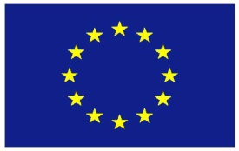

European Union

Statement

WHO

72nd World Health Assembly

(20-28 May 2019)

________

Agenda item – Pandemic Influenza Preparedness

________

Geneva, 23 May 2019

- CHECK AGAINST DELIVERY –

WHO
72nd World Health Assembly
(20-28 May 2019)

Agenda item – Pandemic Influenza Preparedness

EU Statement

Honourable Chair,
Distinguished Director-General,
Colleagues,
I am speaking on behalf of the European Union and its Member States.
[ALIGNMENT PARAGRAPH]
In the case of the next influenza pandemic, the WHO Pandemic Influenza Preparedness Framework guaranties access to vaccines, medicines and diagnostics in all countries in the world, especially in those of most needs. This is why the continued functioning of both the GISRS influenza laboratory network and the PIP Framework is of high importance to the EU and its Member States.
The basis of the pandemic influenza preparedness is in continued monitoring and sharing of influenza viruses by the GISRS laboratory network. The changing international legal environment has created potential challenges in sharing of influenza viruses and legal uncertainty as regards the functioning of the PIP Framework. We support the steps included in the decision in this agenda item to collect information on the functioning of virus sharing to understand the situation better.
We also welcome the change to the footnote of Annex 2 of the PIP Framework, as we believe it contributes to improved benefit sharing under the Framework.
Finally, we call on the secretariat to continue liaising with the CBD secretariat to work on the open questions and the way forward.

